**Section - b : 25 Marks**

**Instructions :**

1. **This section is openbook**
2. **Write the answer next to the question in this word document.**
3. **Submit this word document and the R file in a zip folder**

Attribute Information:

Input variables:

# bank client data:

1 - age (numeric)

2 - job : type of job (categorical: 'admin.','blue-collar','entrepreneur','housemaid','management','retired','self-employed','services','student','technician','unemployed','unknown')

3 - marital : marital status (categorical: 'divorced','married','single','unknown'; note: 'divorced' means divorced or widowed)

4 - education (categorical: 'basic.4y','basic.6y','basic.9y','high.school','illiterate','professional.course','university.degree','unknown')

5 - default: has credit in default? (categorical: 'no','yes','unknown')

6 - housing: has housing loan? (categorical: 'no','yes','unknown')

7 - loan: has personal loan? (categorical: 'no','yes','unknown')

# related with the last contact of the current campaign:

8 - contact: contact communication type (categorical: 'cellular','telephone')

9 - month: last contact month of year (categorical: 'jan', 'feb', 'mar', ..., 'nov', 'dec')

10 - day_of_week: last contact day of the week (categorical: 'mon','tue','wed','thu','fri')

11 - duration: last contact duration, in seconds (numeric). Important note: this attribute highly affects the output target (e.g., if duration=0 then y='no'). Yet, the duration is not known before a call is performed. Also, after the end of the call y is obviously known. Thus, this input should only be included for benchmark purposes and should be discarded if the intention is to have a realistic predictive model.

# other attributes:

12 - campaign: number of contacts performed during this campaign and for this client (numeric, includes last contact)

13 - pdays: number of days that passed by after the client was last contacted from a previous campaign (numeric; 999 means client was not previously contacted)

14 - previous: number of contacts performed before this campaign and for this client (numeric)

Output variable (desired target):

15 - y - has the client subscribed a term deposit? (binary: 'yes','no')

**Logistic Regression and Trees (Classification Problems) : 6 Marks**

**Q1. Answer the following questions from the dataset “bank-full.csv”**

Read the dataset and split into test and training sets and before splitting set the seed to 1000 and 60% should go into the training set.

1. Build a logistic regression model(model1) for predicting “y” with the help of the variables “age”, “balance”, ”campaign” and “duration”. Build another regression model (model2) with above-mentioned attributes excluding “campaign”. Specify the AIC value in both the models and mention which is the best model among both.

**Answer: AIC for model 1 = 15851, AIC for model 2 = 16038. Model1 is the best**

2. Compute the values of Sensitivity, Specificity for the above model (with the campaign).

**Answer: Sensitivity = 0.1652855, Specificity = 0.9839465**

3. Make predictions on the test set and Compute the AUC of the “model1”

**Answer: 0.8094504**

4. Build a CART model for predicting “y” with the help of the variables “age”, “balance” and “duration”. Plot it and mention the number of splits you see in the plot.

**Answer: 2**

**5.** Make predictions on test data using the model created in above Problem 2 and compute the value of AUC.  **Answer: 0.8040856**

6. What proportion of the customers are “Married” and have a “technician” job.

**Answer: 0.08962421**

**Text Analytics and Clustering**

**Q2. Answer the below questions from the dataset “Movies.txt”**

Load the data into R and assign the following variables as the column names in the same order.

"ID","Title","ReleaseDate","VideoReleaseDate","IMDB","Unknown","Action","Adventure","Animation","Childrens","Comedy","Crime","Documentary","Drama","Fantasy","FilmNoir","Horror","Musical","Mystery","Romance","SciFi","Thriller","War","Western"

1) Eliminate the first four variables from the dataframe. What is the number of movies which belong to both “action” and “horror” category. **1Mark**

**Answer: 13**

2) Build a hierarchical clustering model with the Euclidean distances. Plot the dendogram. What is the number of clusters at a height of 150?  **1Mark**

**Answer: 3**

3) Split the above model into 7 clusters. What are the clusters with a maximum and minimum number of observations?  **1Mark**

**Answer: maximum = cluster2, minimum = cluster7**

4) What is the number of Adventure category movies in Cluster 1 of the above model.  **1Mark**

**Answer: 56**

5) Which is the cluster with the highest number of movies belonging to the “Children” category?  **1Mark**

**Answer: cluster 1**

6) Which is/are the clusters with the least number of movies belonging to the “Fantasy” category. **1Mark**

**Answer : cluster 3,4,5,6,7**

7) Build a K-means clustering model with seed value 1000 and same number of clusters. Mention the clusters which have the highest and least number of observations.

**0.5Mark**

**Answer : highest = cluster3, least = cluster4**

8) Which Hierarchical Cluster best corresponds to K-Means Cluster 6? **0.5**

**Answer : cluster5**

9) Which Hierarchical Cluster best corresponds to K-Means Cluster 4? **0.5**

**Answer : cluster7**

10) Which Hierarchical Cluster best corresponds to K-Means Cluster 3? **0.5**

**Answer : cluster2**

11) Which K-means cluster has got more number of movies belonging to “Action” genre.**0.5**

**Answer : cluster1**

12) Which K-means cluster has got more number of movies belonging to “War” genre. **0.5**

**Answer : cluster3**

**Text Analytics : 5 Marks**

**Q3.** **Answer the below questions using the dataset “energy_readings.csv”**

1) What is the number of observations in the dataset. What is the proportion of emails that are responsive in the dataset.

**Answer : observations = 855, responsive emails = 139**

2) Convert all alphabets into lowercase, remove punctuations, eliminate stop words and go for stemDocument and also remove sparse terms.

Build a CART model(classification) with seed value 1500 and train the model with 75% of the observations and plot the model. Spar = 0.95

3) Make predictions on the test set and mention the proportions of responses with value more than (i)0.5 (ii)0.7 (iii)0.9

**Answer : (i) 35, (ii)35, (iii)35**

4) What is the accuracy of the model with predicted response of the test set (i)>0.6 (ii)0.8

**Answer : (i) 0.8364486, (ii) 0.8364486**

5) Plot the ROC curve for the model and computer the value of AUC.

**Answer : 0.6146049**

**Visualization : 5Marks**

**Q4. Answer the following questions from the climate_change.csv dataset**

1) Load the data into R and find out the number of observations and the number of unique years.

**Answer : observations = 308, unique years = 26**

2) Plot the variables “N2O” and “Temp” on X and Y axes respectively and make it a line plot. Name the axes as “Concentration of N2O” and “Temperature” respectively.

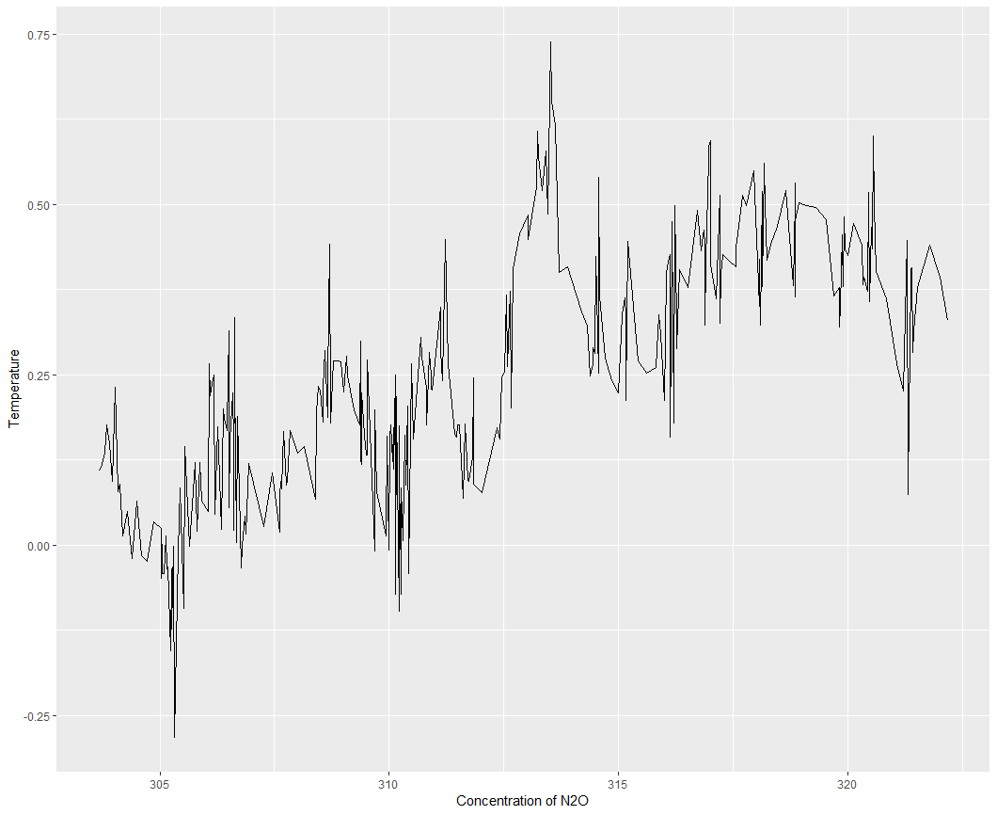

3) Build a linear regression model to predict “Temp” over “Aerosols” and plot the linear equation using ggplot2.(Go for a line graph) Also plot the regression line.

**Image:** 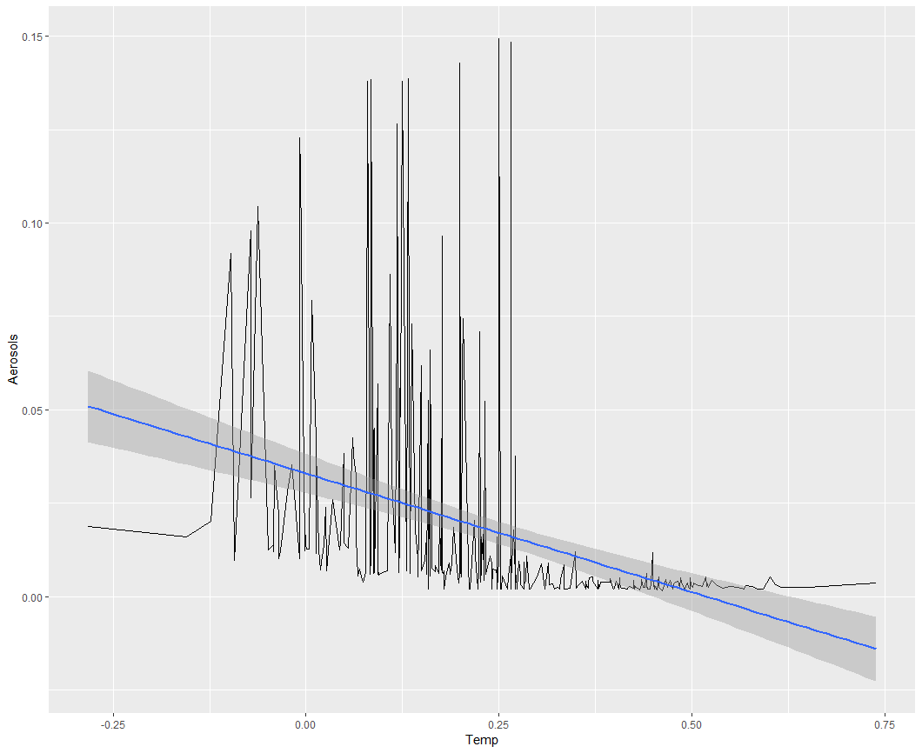

**Answer the following questions from “intl.csv”**

4) Plot the bar chart with region on X-axis and Percentage of International students on Y axis. Keep the stat as “identity” and fill in the bars with red color and add label “International Students Percentage” on y axis and the element text angle of 90 and horizontal justification of 1.

**Image:**

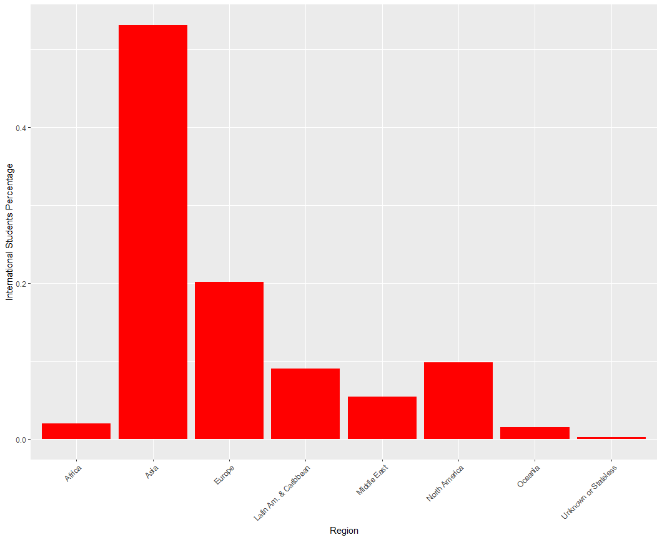

5) Plot the pie chart with the regions as the labels.

**Image:**

